Project Design Phase-II
Technology Stack (Architecture & Stack)

Date | 29 July 2026
Team ID
Project Name | Plugging into the Future: An Exploration of Electricity Consumption Patterns
Maximum Marks | 4 Marks

Technical Architecture:
The Deliverable shall include the architectural diagram as below and the information as per the table1 & table 2
Example:
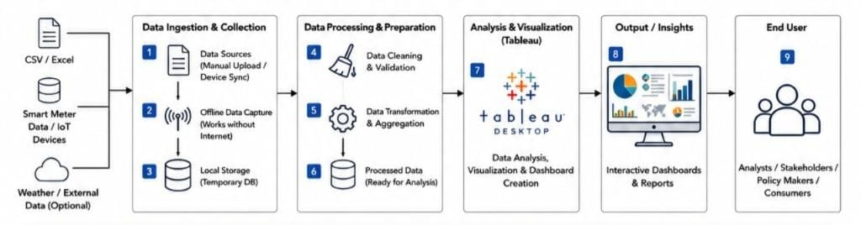

Table-1 : Components & Technologies:
S.No | Component | Description | Technology
1 | User Interface | Interactive dashboard for visualizing electricity consumption trends and analysis. | Tableau Public / Tableau Desktop
2 | Data Source | Stores electricity consumption data for analysis. | CSV Dataset / Excel Dataset
3 | Data Processing | Cleans, filters, and prepares electricity consumption data before visualization. | Tableau Prep / Tableau Desktop
4 | Data Visualization | Creates charts, graphs, maps, KPIs, and dashboards for analysis. | Tableau
5 | Dashboard Filters | Enables filtering by state, month, year, and consumption category. | Tableau Interactive Filters
6 | Data Analytics | Performs trend analysis, state-wise comparison, and consumption pattern analysis. | Tableau Calculated Fields & Analytics
7 | Reporting** | Generates reports and dashboard summaries for stakeholders. | Tableau Dashboard / PDF Export
8 | File Storage | Stores the dataset and Tableau workbook. | Local File System (.csv, .xlsx, .twb, .twbx)
9 | Project Website (Optional) | Hosts the Tableau dashboard for online access. | HTML, CSS, JavaScript, GitHub Pages
10 | Dashboard Publishing | Publishes the dashboard for public viewing and sharing. | Tableau Public
11 | Infrastructure (Deployment)** | Deployment of the dashboard on local system or cloud platform. | Local Computer / Tableau Public / GitHub Pages

Table-2: Application Characteristics:

Characteristics | Description | Technology
Open-Source Frameworks | Open-source technologies used for developing and hosting the project website and dashboard. | HTML5, CSS3, JavaScript, GitHub Pages
Security Implementations | Access to the Tableau workbook and dataset is restricted to authorized users during development. Published dashboards use secure HTTPS connections. | HTTPS, Tableau Public Security, GitHub Security
Scalable Architecture | The dashboard is designed to accommodate larger electricity consumption datasets with minimal modifications and supports easy updates. | Tableau Desktop, Tableau Public
Availability | The dashboard is available online through Tableau Public and can be accessed anytime using a web browser. | Tableau Public, GitHub Pages
Performance | Optimized dashboard with interactive filters, calculated fields, and efficient visualizations to ensure fast loading and smooth user interaction. | Tableau Optimization, Interactive Filters, Calculated Fields

